AtliQ Hardware 3

Section 1 - The Company 3

Stakeholders 3

Section 3 - The Situation 3

Section 4 - The Problem 3

Section 5 - The Solution 3

Section 6 - Success Criteria 3

Dashboard Requirements 4

Section 7 - The Data 4

Section 8 - Power BI – First Draft 4

Setting up the relationships 5

ETL (Extract, Transform, Load) 5

Step 1) - 5

Step 2) - 6

Step 3) - 7

Building the dashboard – First Draft 8

Creating a Revenue and Sales Quantity measures 8

Populating the dashboard with the new measures 8

Revenue and Sales Qty by Market 8

Adding a year slicer 9

Adding a month slicer 9

Top 5 Customers and Products 9

Revenue trend 10

Final requirements 10

SQL Check 12

Section - 9 Power BI – Second Draft 12

Total Profit Margin Card 13

Profit Margin % and Profit Contribution % by market 13

Dynamic Title(s) 14

Customer Table 15

Profit Margin % by Zone 16

Market and Customer Drill Down 16

Profit Target Slider 16

Step 1) - 16

Step 2) - 17

Step 3) - 17

Step 4) - 17

Step 5) - 17

Revenue trend 2.0 18

# 

# 

# AtliQ Hardware

## Section 1 - The Company

supply hardware and peripherals to 4 main stores in India

* Surge stores
* Nomad stores
* Excel stores
* Electricalsara stores

Section 2 - The People and Offices  
There is a head office in Delhi. The company has many offices in India.

There are 3 regional managers 1 for North 1 for central and 1 for South India.

### Stakeholders

* The Sales Director is Bhavin Patel
* The IT team (Falcons)
* Marketing Team
* Customer Service team
* Data and Analytics team (Data Masters)

## Section 3 - The Situation

When Bhavin Patel wants sales insights, he must phone all 3 regional directors. All 3 managers paint him a picture that show their region is trending positive, but he sees overall that sales are declining. When he asks for the specific numbers/data they each send him 60+ Excel files which he has not got the time to analyse and find out himself. He is frustrated that the regional directors can’t give him simple statistics and point to the biggest areas of potential growth. If there is a region where sales are declining Bhavin Patel would like to introduce a promotion offer or try and reach out to customers in a better way to increase sales.

## Section 4 - The Problem

Bhavin Patel is interested in a Power BI dashboard that shows all the data and where he can set up monthly report emails. From this dashboard he can then make data driven decisions.

## Section 5 - The Solution

An automated dashboard providing quick and latest sales insights to support data driven decision making.

## Section 6 - Success Criteria

Bhavin Patel has put a 3-month timeline to achieve the following criteria:

* Dashboard uncovering sales order insights with latest data available
* Sales team able to take better decisions and prove 10% cost savings of total spend
* Sales Analysts stop data gathering manually in order to save 20% of their business time and reinvest it value added activity (Currently wasting time joining/merging excel files)

### Dashboard Requirements

The Sales director has asked for the following on the dashboard

1. Revenue by markets
2. Sales Qty by markets
3. Revenue trend
4. Top 5 Customers by revenue
5. Top 5 Products by sales quantity
6. Be able to answer the following questions
   * Show total revenue in year 2020
   * Show total sales quantity in Jan 2020
   * Show total revenue in year 2020 from the Chennai market

## Section 7 - The Data

Falcons team is a team of software engineers that own the sales management system. All the sales record are stored in a MySQL data base. The Data masters ask the Falcons to use the MySQL database as they will use it as a source in the Power BI tool and they will build a dashboard on top of it

Note (Typically the following would happen in a real-world example)

Rather than query the MySQL database directly the data is copied to a data warehouse via ETL (Extract, Transform and Load) this job is done by the data engineers. If the data analysts were to query the MySQL database directly, they run the risk of slowing down the database and the data is not likely in a format that the data master's would want. So instead, the data analysts pull the data from the data warehouse and build the dashboard from that.

For simplicity we will plug the raw MySQL database into the Power BI dashboard.

## Section 8 - Power BI – First Draft

Connecting the MySQL server to Power BI

1. Selecting the “Get data” option from the “Home” tab on the ribbon.
2. Select the “More...” option at the bottom of the drop down
3. Select “MySQL database” and press “Connect”
4. Enter the Server name and the Database name in my instance it is “localhost” and “sales” respectively
5. Select the database tab from the left-hand side and enter your database username and password
6. Select all the tables within the navigator window and click “load”

### Setting up the relationships

Here you can see all the tables have been loaded by looking at the “Model View” Notice how some of the relations have been transferred across to power BI.

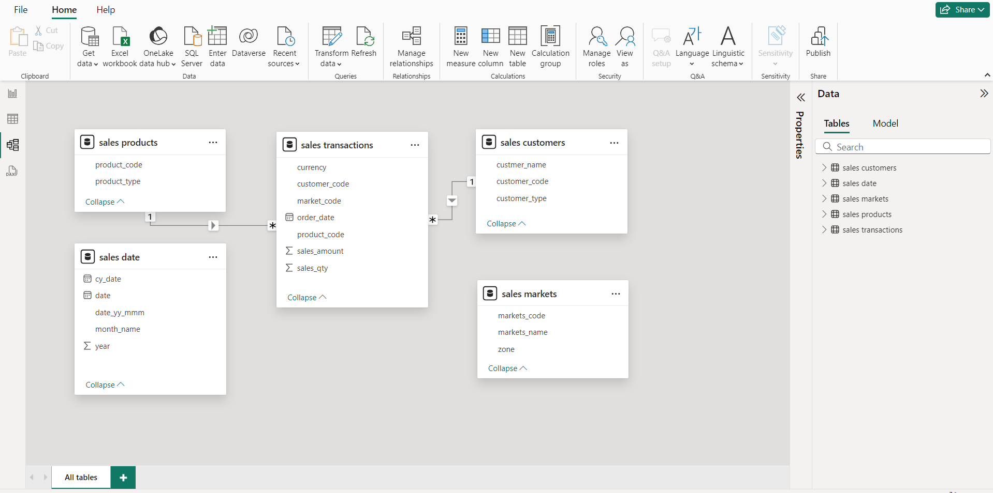

I will finish adding the other relations. Note this is a star schema. The centre table is the **Fact table,** and the other tables are the **dimension tables.**

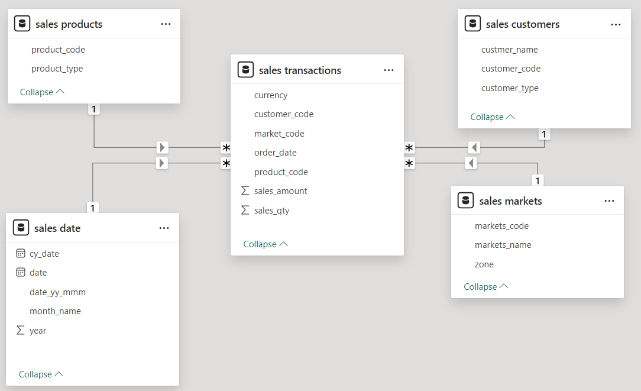

### ETL (Extract, Transform, Load)

To transform the data, select “Transform data” on the “Home” ribbon to open the “Power Query Editor”

#### Step 1) -

Within the “sales markets” table there are 2 market names that have no corresponding zone. These are “New York” and “Paris”. From the brief we know AtliQ only operate in India. So these areas will be ignored. (The reason for their exitance could be there was 1 of purchase in these areas and the data engineers or data scientist did not fully add the new areas to the database.)

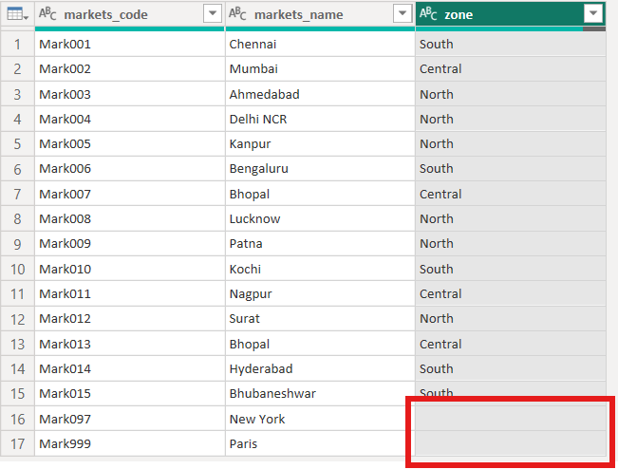

To ignore them I select the drop down on the “zone” column header and deselect the “(blank)” field. After clicking OK, Power BI tracks the transformations steps I have made. These steps can be seen on the right-hand side window

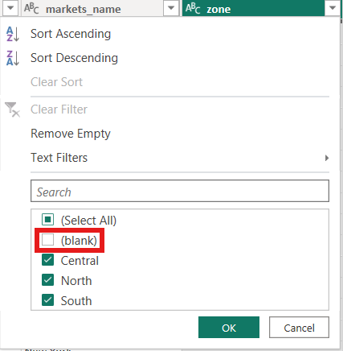 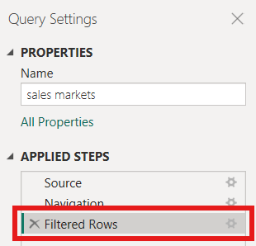

#### *Step 2) -*

There are some zero and negative values in the “transactions” table in the “sales_amount” field. These also will be removed for simplicity's sake.

SELECT product_code, sales_amount  
FROM transactions  
WHERE sales_amount <=0;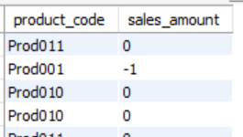

The total amount can be seen by editing the query slightly.

SELECT COUNT(sales_amount) AS Total_zero_or_less_sales  
FROM transactions Total_zero_or_less_sales WHERE sales_amount <=0; 1611

I then filtered these out on Power BI same as before by deselecting the values from the appropriate drop down.

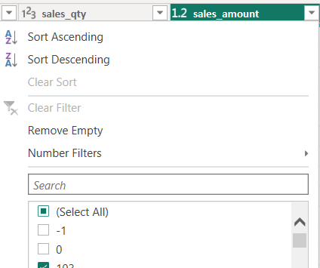

#### *Step 3) -*

There are some values in the “currency field that are in “USD” not “INR” this would cause inaccuracies if they added up as they are different currencies. To solve this, I added another column called “norm_sales_amount” where all the values will be converted into “INR”. This is a bit simplified but 1 x USD = 75 INR. To do add the column I used the “Add Column” tab on the ribbon. Then selected “Custom Column” and named it “norm_amount” and entered the following code:

= each if [currency] = "USD" or [currency] ="USD#(cr)" then [sales_amount]*75 else [sales_amount]

"USD#(cr)" indicates that the currency value might include a hidden carriage return character (Return/Enter) at the end, which can happen if the data was imported or formatted in a way that accidentally included such characters.

Once again, this operation has been tracked in the right-hand window.

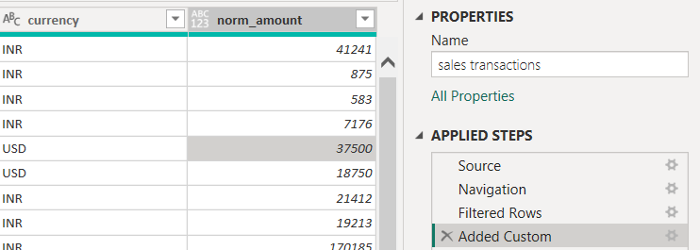

With noticing the carriage return in some of the currency values I wanted to remove all of them at the source rather than in Power BI. I did this in case I have to use this field again. To do this I used the following Queries. I kept the comments in for explanation.

# Identify the Affected Rows  
SELECT * FROM transactions  
WHERE currency LIKE '%\r%';

# Turn safe mode on  
SET SQL_SAFE_UPDATES = 0;

# Update the Data by using the REPLACE function  
# Note(Carriage return characters are represented by \r in MySQL and '' is an empty string)  
UPDATE transactions  
SET currency = REPLACE(currency, '\r', '');

# Turn safe mode back on  
SET SQL_SAFE_UPDATES = 1;

Running the first Query I got a list of all the affected rows; I then ran it again after the other queries and got 0 results showing that no more entries had carriage returns in them. I then double checked that it worked in Power BI by checking the drop down in the currency column on the transaction table and now there was only 1 USD and 1 INR whereas before there was 2 of each.

### Building the dashboard – First Draft

#### Creating a Revenue and Sales Quantity measures

The first thing I did was create a new data table where I then created 2 new measures within. I will later use these measures to help populate the dashboard.

1. Select “Enter data” on the Home ribbon and name the table (BaseMeasures)
2. Added 2 new measures to the table by clicking the breadcrumbs on the BaseMeasure table and selecting “New measure” .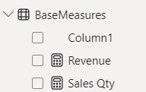
   1. Revenue = SUM('sales transactions'[sales_amount])
   2. Sales Qty = SUM('sales transactions'[sales_qty])

#### Populating the dashboard with the new measures

Using the two new measure I just created I added 2 cards to the dashboard representing each. These will later change dynamically to represent the totals of the data being filtered for.

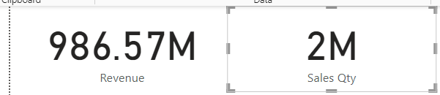

#### Revenue and Sales Qty by Market

The next part of the dashboard I added was a bar chart to show the market share for both revenue and sales qty. I added data labels as a lot of the markets don’t have a big share. I also changed the x-axis to display the quantity in millions rather than billions. Finally, I gave them both a title.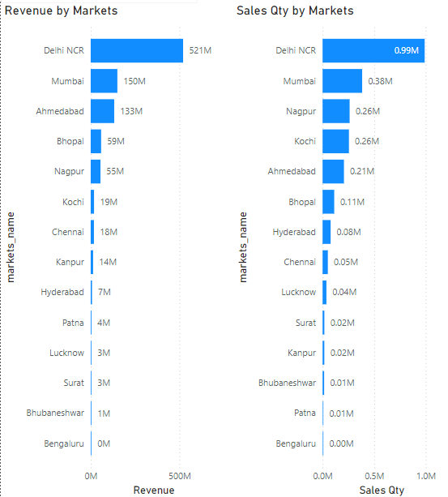

#### 

#### 

#### Adding a year slicer

As this data contains multiple years within it. The sales directors' requirements state that the dashboard can show year specific data. To see multiple years at the click of a button a slicer was the best option as it would dynamically change the data in the dashboard to fit the user's preference.

1. Drag the “year” field from the “sales_date” table into a blank space on the dashboard
2. Select “Slicer” from the “Visualizations” pane: 
3. Then format to preference



#### Adding a month slicer

To be able to see Jan 2020 data I added another level to the dashboard by adding a month slicer. I will use the “cy_date” column from the “sales_date” table. The Formatting for the date was inconsistent so I had to alter it.

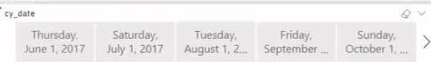

To do this I went on the “Table View” selected the “cy_date” column and within the “Column tools” ribbon changed the format to “Mmm yy” e.g. Jan 20, Apr 19, ... Now when I returned to the dashboard the dates were consistent and after some more formatting the slicers now looked like this:

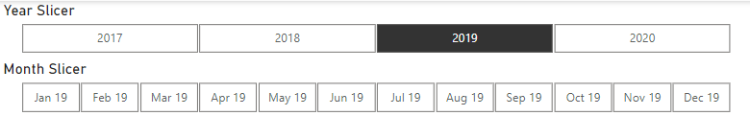

#### Top 5 Customers and Products

Another requirement for the dashboard to include was “top 5 customers by revenue” and “top 5 products by sales quantity”. To do this I created a bar chart similar to the ones made earlier. Instead this time I used the “Filtering pane” to filter only top 5 results. Here is the filtering pane for the top 5 and the resulting graphs after formatting: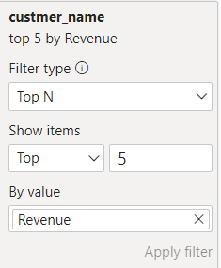

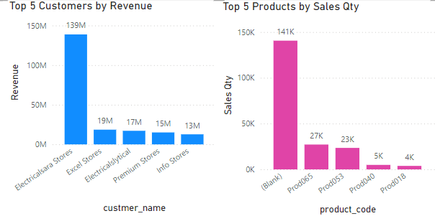

#### Revenue trend

Last on the list is a visual that shows the revenue trend of Atliq. A line graph is best suited to display this. So using “cy_date” on the x-axis and “Revenue” on the y-axis and a bit of formatting I got this line graph:

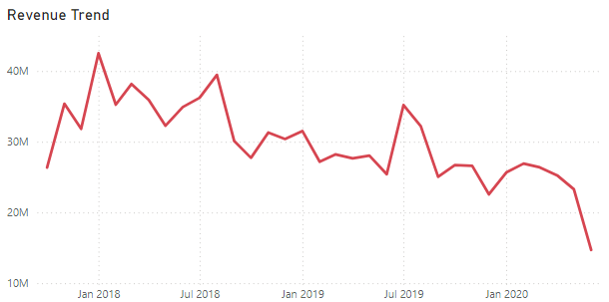

#### Final requirements

Now all the elements have been made, can the dashboard answer the questions set by the sales director?

1. Show total revenue in year 2020

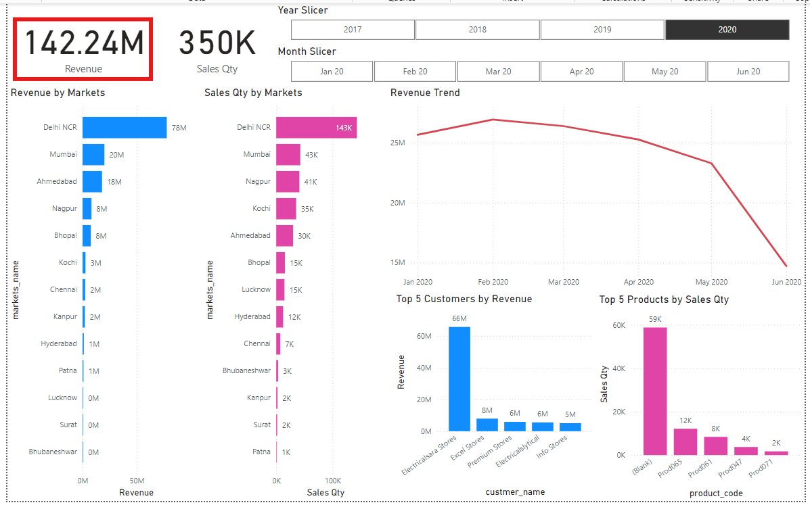

1. Show total sales quantity in Jan 2020

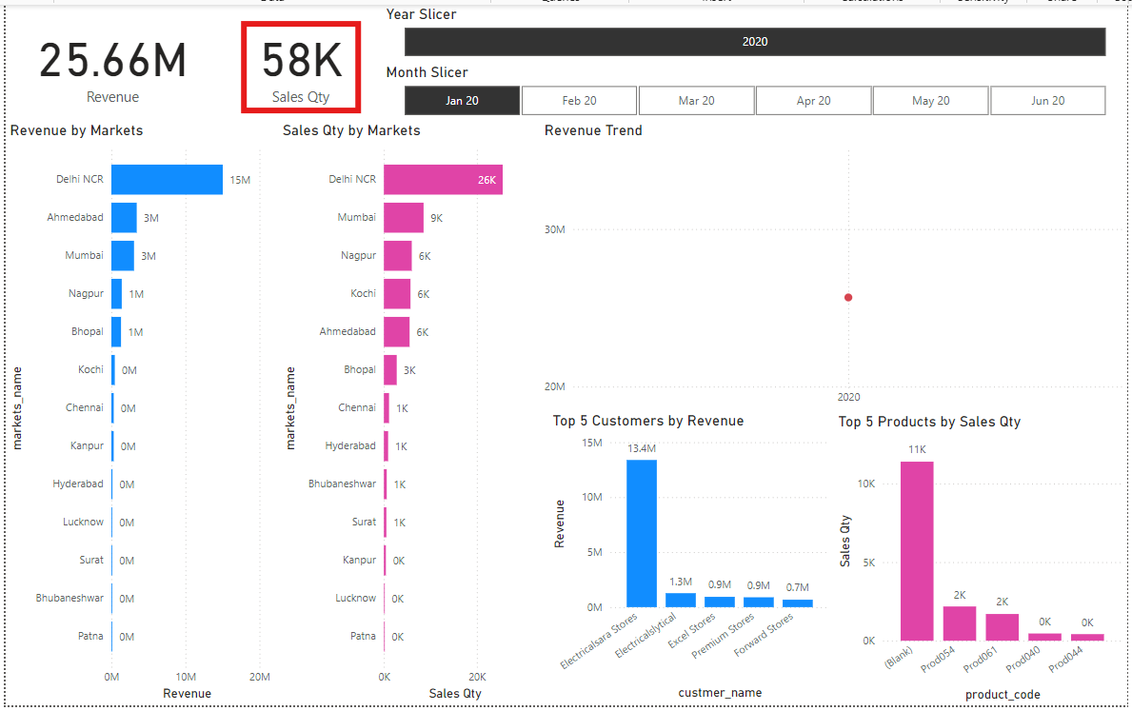

1. Show total revenue in year 2020 from the Chennai market

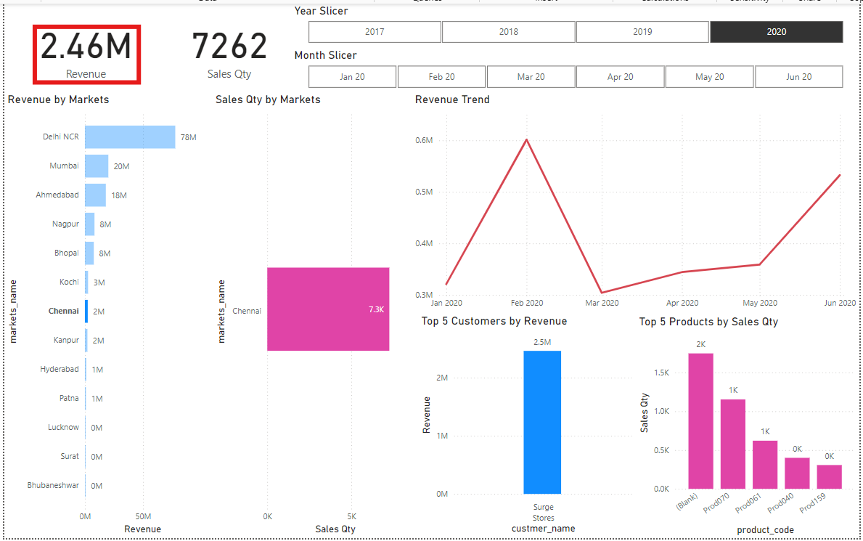

#### SQL Check

Just to be sure I double checked all these values by writing MySQL queries to find the same result. Which they all did.

# Show total revenue in year 2020   
SELECT SUM(transactions.sales_amount) AS Revenue   
FROM transactions   
INNER JOIN date ON transactions.order_date=date.date   
WHERE date.year=2020 and transactions.currency="INR" or transactions.currency="USD";



# Show total sales quantity in Jan 2020   
SELECT SUM(transactions.sales_qty) AS Total_sales_qty  
FROM transactions   
INNER JOIN date ON transactions.order_date=date.date   
WHERE date.year=2020 and date.month_name="January" and (transactions.currency="INR" or transactions.currency="USD");



# Show total revenue in year 2020 from the Chennai market   
SELECT SUM(transactions.sales_amount) AS Revenue   
FROM transactions   
INNER JOIN date ON transactions.order_date=date.date   
WHERE date.year=2020 and transactions.market_code="Mark001";



## Section - 9 Power BI – Second Draft

The sales director is very happy with your first draft but there are some new requirements

* Total Profit Margin card
* Profit Margin % and Profit Contribution % by market
  + dynamic title that changes based on what data is being showed
* Customer Table with the following headers:
  + Revenue, Revenue Contribution % and Profit margin %
* Profit Margin % by Zone
  + Ability to drill down to markets within zones
    - Drill further down to customers within markets
  + Profit target slider that has a red alert depending on the user's choice
* Revenue trend that compares previous years Revenue with current year + a Profit margin % line

Also, the data engineers have added 3 new columns to the MySQL database in order for you to edit your dashboard to meet the new requirements:

* profit_margin_percentage
* profit_margin
* cost_price

#### Total Profit Margin Card

To find the total profit I had to create a new measure within the base measure table

Total Profit Margin = sum('sales transactions'[profit_margin])

Then just used this measure to fill the card

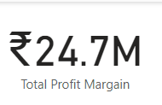

#### Profit Margin % and Profit Contribution % by market

Again, I had to create 2 new measures in order to display them on visual.

**Profit Margin %** = DIVIDE([Total Profit Margin],[Revenue],0)

**Profit Margin Contribution %** = DIVIDE([Total Profit Margin],CALCULATE([Total Profit Margin],ALL('sales products'),ALL('sales customers'),ALL('sales markets')))

**Profit Margin %** is self-explanatory.

The **Profit Margin Contribution %** measure calculates the % contribution of the filtered data to the overall profit margin. It shows how much of the total profit margin is attributable to the specific set of filters currently applied in the report.

Numerator: The profit margin for the specific set of filters (e.g., a particular product, customer segment, or market).

Denominator: CALCULATE([Total Profit Margin], ALL(...)), calculates the total profit margin but with all filters on 'sales products', 'sales customers', and 'sales markets' removed. This gives the overall profit margin without any specific product, customer, or market filters.

After these measures where made it was simple as using them for the x – axis. I then formatted the title to match

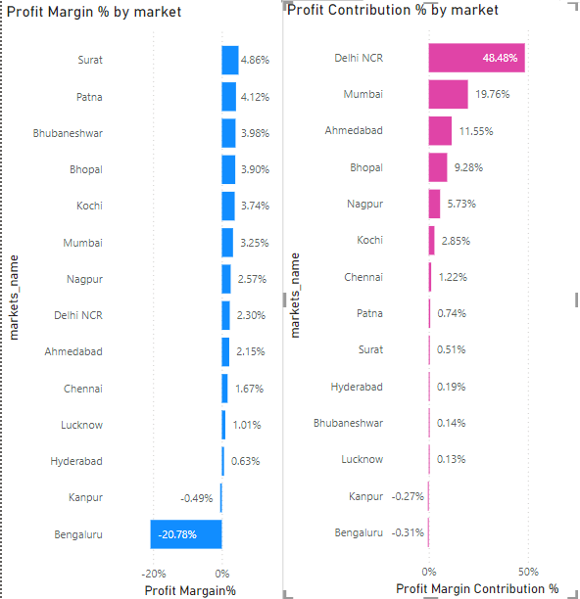

#### Dynamic Title(s)

Now the graphs were made I had to make the title change based on what filters were selected on both slicers. Here is the DAX code of the measure I created.

Variables:

* **Subyearvalue**: This variable captures the selected year from the 'sales date'[year] column. If no year is selected, it returns BLANK().
* **MonthList**:
  + VALUES('sales date'[cy_date]) returns a unique list of the 'cy_date'
  + CONCATENATEX concatenates these dates into a single string, formatted as "mmm yy" (e.g., "Jan 21"), separated by ", ".
* **YearPart**:This variable checks if a specific year (Subyearvalue) has been selected. If it has, it includes that year in the title; otherwise, it leaves this part blank.
* **MonthsPart**: This variable checks if the MonthList (a list of selected months) is not blank. If it is not blank, it includes the formatted list of months in the title; otherwise, it leaves this part blank.

The RETURN statement creates the final title based on the applied filters. (3 states)

* **When 'cy_date' is filtered**: If the 'cy_date' column is filtered, the title includes the text "Profit Margin % by market -" followed by the months in MonthsPart.
* **When only 'year' is filtered**: If the 'year' column is filtered and a specific year is selected (Subyearvalue is not blank), the title includes the text "Profit Margin % by market -" followed by the selected year (YearPart).
* **Default title**: If neither 'cy_date' nor 'year' are filtered, the default title is simply "Profit Margin % by market".

Dynamic Chart Title_1 =

VAR Subyearvalue = SELECTEDVALUE('sales date'[year])

VAR MonthList = CONCATENATEX(

VALUES('sales date'[cy_date]),

FORMAT('sales date'[cy_date], "mmm yy"),

", "

)

VAR YearPart = IF(NOT(ISBLANK(Subyearvalue)), Subyearvalue, "")

VAR MonthsPart = IF(

NOT(ISBLANK(MonthList)),

MonthList,

""

)

RETURN

IF(

ISFILTERED('sales date'[cy_date]),

"Profit Margin % by market - " & MonthsPart,

IF(ISFILTERED('sales date'[year]) && NOT(ISBLANK(Subyearvalue)),

"Profit Margin % by market - " & YearPart,

"Profit Margin % by market"

)

)

I then created another measure Dynamic Chart Title_2 and just replaced "Profit Margin % by market" with "Profit Contribution % by market".

To enable the measure on the title, select the “Title” from the “General” tab and the select the “fx” button and change the “What field should we base this on?” to the measure. Then did the same for "Profit Contribution % by market" and used Dynamic Chart Title_2.

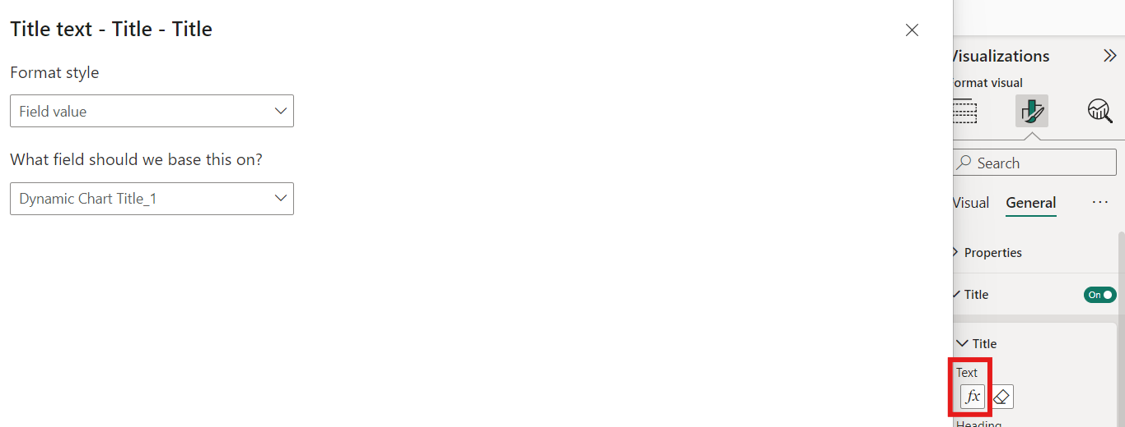

Here is some demos of it working:

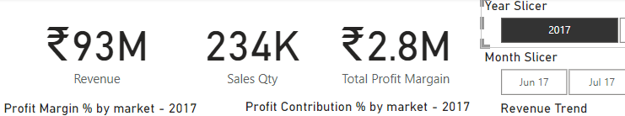

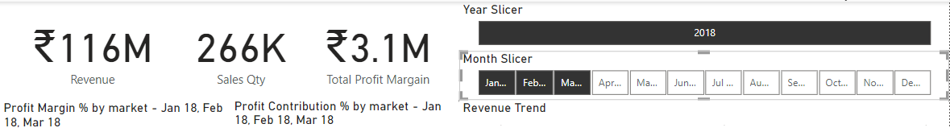

#### Customer Table

Table was pretty straight forward. I just selected the table viz and populated it with the headers required.

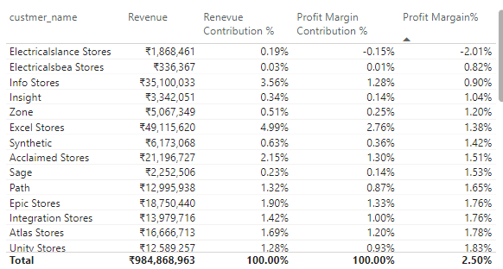

#### Profit Margin % by Zone

I then created another sheet. Otherwise, all the graphs would have been too cramped. I kept the same cards and slicers at the top as well as the customer table. Before making the Profit Margin % by Zone viz I created another dynamic measure/title for it. Then simply put “Zone” in the y-axis and Profit Margin % in the x-axis

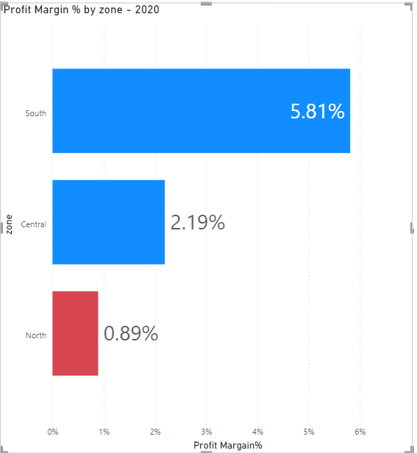

#### Market and Customer Drill Down

Adding further drill downs was as simple as adding more fields to the y axis making sure they are in the correct order:

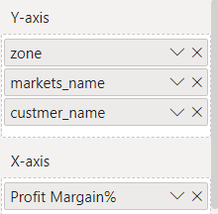

Once this was done it enables drill down on the graph:

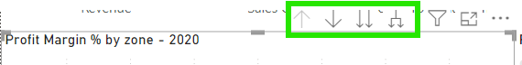

#### Profit Target Slider

##### Step 1) -

Select the visual, then on the “Modelling” tab of the ribbon select “New parameter” and “Numeric range”

##### Step 2) -

Fill out the window as follows:

This will create a slider and generate a new table and measure called “Profit Target” and “Profit Target Value” respectively.

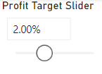

##### *Step 3) -*

Select the “Profit Target Value” measure and format it as “%”

##### *Step 4) -*

In order for the slider to change the colour of the bars based another measure has to be created which is what the viz will be checked against. I created this measure within the “Profit Target” table:

Target Diff = [Profit Margin%]-'Profit Target'[Profit Target Value]

##### *Step 5) -*

Like the dynamic title within formatting the colour of the bars press the “fx” button and fill out as below:

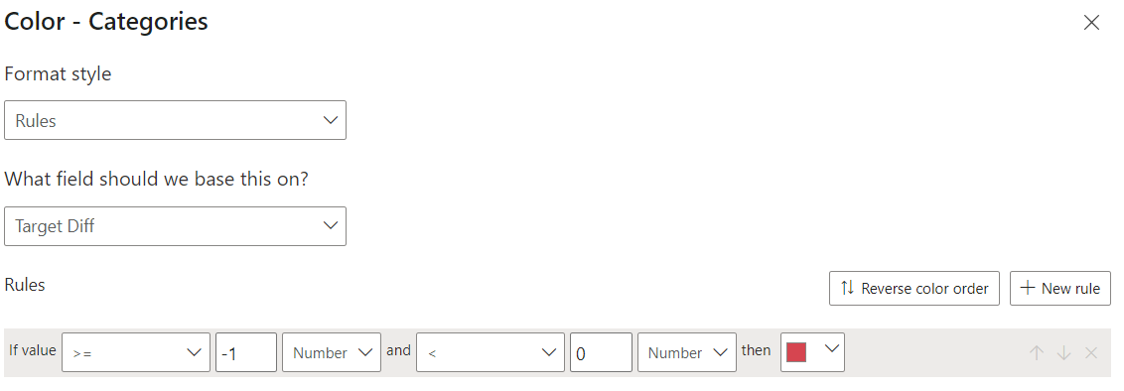

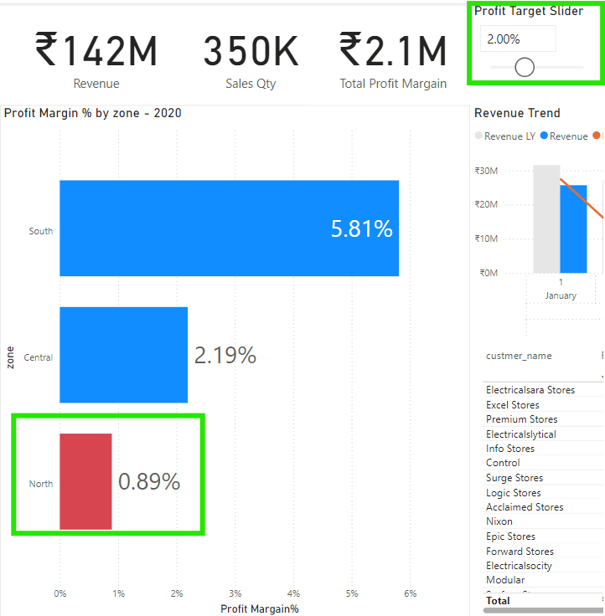

Now the bar will turn red if the value of it is less than the slider

#### 

#### Revenue trend 2.0

The last part to add is the new revenue trend that compares current years revenue with the previous. First thing was to create a new measure to see the previous years:

Revenue LY = CALCULATE([Revenue], SAMEPERIODLASTYEAR('sales date'[date]))

Then used this measure as well as “Revenue” and “Profit Margin %” to populate the fields of Line and clustered column chart:

